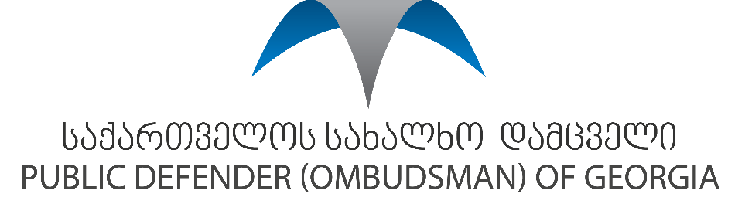

Social protection and social security in Georgia
The elderly people represent one of the most vulnerable groups in the country. Existing mechanisms for the protection of rights of the elderly fails to respond to modern day challenges and international requirements.
The rights to the social security and social protection is recognized in the several legal provisions, such as - the law of Georgia on State Pensions, Law of Georgia on Social Assistance, Law of Georgia on Funded Pensions and the only political framework developed by the government - 2017-2018 action plan of the state policy on aging in Georgia.
The majority of older people do not have access to adequate housing, social services and protection mechanisms and therefore, live below the poverty line, lacking the shelter and are under risk of isolation. Social guarantees offered by the state often fail to even ensure minimal standards of living of these persons. Shortage of programs designed for them and measures implemented on a local level to ensure their wellbeing do not satisfy appropriate needs of the group.
The existing social assistance system for elderly is basically limited to the issuance of a retirement pension to citizens having reached the retirement age (60 years for women and 65 years for men). This is a non-contributory pension scheme, which provides a flat rate benefit to all persons of eligible age. The amount of the pension is too low to guarantee affordability of nutrition and medication. The Georgian government has currently adopted a new Law on Pension, with the aim of ensuring the financial sustainability of the existing old-age pension, defined as social pension and of increasing the Income Replacement Rate pensioners enjoy once they stop working. The main feature of the proposed reform is the introduction of a private pension saving system along with the existing old-age pension, to generate a supplementary pension at the time of retirement. The private pension saving system will be based on contributions paid by employees and by employers, which are expected to be complemented by government’s contributions. It has been two months since the private pension savings scheme has been enacted. Therefore, it is the subject of observation and monitoring whether the system will efficiently provide future generations of pensioners with a better income at retirement.
Elderly persons represent a target group of separate subprograms of the State Program for Social rehabilitation and Child Care supporting the rehabilitation of war veterans (provision of assistive devices, community organizations). Therefore, the existing programs and services are not focused on specific needs of elderly people.
The state is only providing minimum subsistence allowance or boarding house services for these individuals. There are no targeted programs developed for elderly people. They can benefit from social programs only after getting registration in a common database on socially vulnerable families and are awarded the subsistence allowance. They should satisfy prescribed requirements to be awarded with minimum subsistence allowance.

Action plan was adopted at the end of 2017. As a result, the responsible entities were left with only one year to fulfill the obligations set forth in the action plan.
Law of Georgia on Funded Pensions, available at: <https://matsne.gov.ge/en/document/view/4280127?publication=0> [accessed Jan. 27, 2019].

